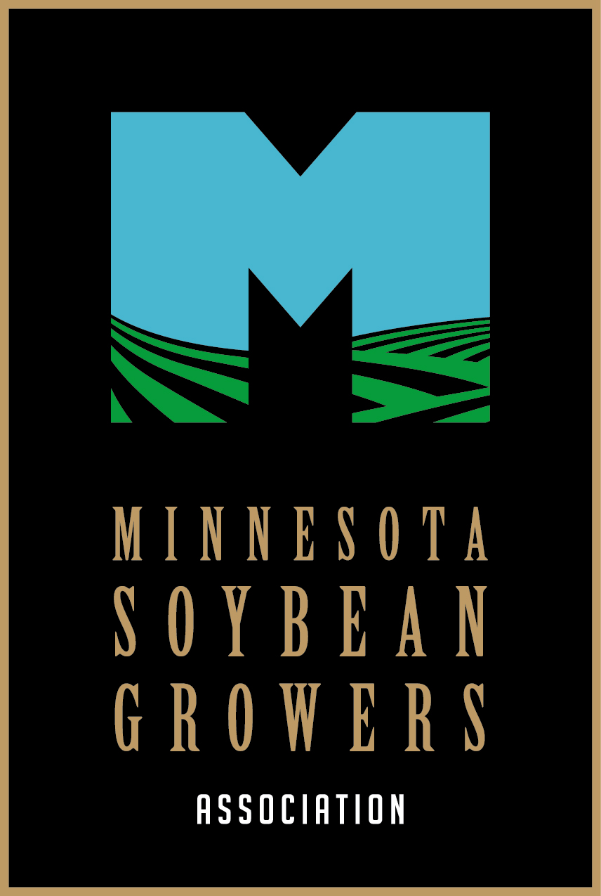

Dear Chair Putnam,
The Minnesota Soybean Growers Association (MSGA), which represents the interests of our members and Minnesota’s nearly 26,000 soybean farmers, strongly opposes SF3083.
In recent times, the agricultural sector has witnessed significant advancements in seed technology, particularly in the treatment of seeds to enhance their resilience against pests, diseases, and environmental stresses. As a fourth-generation family farmer, I would like to share some insights into the stringent and current regulations governing the use and distribution of treated seeds.
The bill is simply not needed, as the chemicals included in treated seed are already regulated by federal law and rules. Additionally, the section of the bill related to verification of need before planting treated seeds is an unnecessary step, and I’m happy to expound on the reasons behind this stance.
Firstly, treated seeds are designed to enhance the growth and productivity of crops, offering protections against pests, diseases, and adverse environmental conditions. The benefits of these seeds are well-documented and widely recognized within our agricultural community. Farmers who choose to use treated seeds do so with the intention of improving their crop yield and ensuring the health and viability of their produce. The efficacy of treated seeds is not only a matter of scientific consensus but also of practical experience, as numerous farmers have witnessed significant improvements in their agricultural outcomes.
Secondly, the verification process itself can introduce delays and complications that hinder the timely planting of crops. Agriculture is a time-sensitive endeavor in which the planting season and optimal growing conditions must be meticulously adhered to. By imposing a verification requirement, we risk disrupting these crucial timelines, potentially leading to reduced yields and economic losses for farmers and Minnesota’s economy. It is vital to ensure that farmers have the autonomy to make swift decisions based on their knowledge and expertise, without being encumbered by bureaucratic procedures.
Moreover, the verification of need presumes that there is a one-size-fits-all criterion for the utilization of treated seeds. In reality, farming conditions vary drastically depending on geographic location, soil type, weather patterns, and the specific challenges faced by individual farmers. This diversity makes it impractical to establish a universal standard for verification that would adequately address the unique needs of every farming operation. Farmers are the most qualified individuals to assess their own requirements and determine the best course of action for their crops.
Lastly, the agricultural sector is already subject to numerous regulations and standards to ensure the safety and quality of produce. Adding another layer of verification may result in redundancy and inefficiency. It is essential to streamline regulatory processes to facilitate the growth and development of the agricultural industry, rather than hinder it with excessive and unwarranted procedures.
In conclusion, the planting of treated seeds should not be subjected to verification of need. The proven benefits, time-sensitive nature of farming, the variability of agricultural conditions, the promotion of sustainable practices, and the existing regulatory framework all substantiate the argument against such verification. It is imperative that we empower our farmers to make informed decisions independently and foster an environment conducive to agricultural innovation and success.
Thank you for considering our perspective.
Sincerely,
Darin Johnson,
President, Minnesota Soybean Growers Association

